Analysis of Obesity Factors and Prediction Models

Dinesh Ram Veerappan Kosal, DeVos School of Mangamenet, Northwood University.

# Abstract

This paper presents an analysis of various factors contributing to obesity levels in individuals. Using a comprehensive dataset, we explore the relationships between demographic, dietary, and lifestyle factors and their impact on obesity. Through exploratory data analysis, regression modeling, classification techniques, and clustering algorithms, we aim to identify key predictors of obesity and develop accurate prediction models. Our findings provide insights into the complex nature of obesity and offer potential strategies for targeted interventions in obesity prevention and management.

# Problem statement

The dataset "ObesityDataSet_raw_and_data_sinthetic.csv" contains information about various factors that may contribute to obesity. The goal of this analysis is to explore the relationships between these factors and obesity levels, develop predictive models to classify individuals into different obesity categories, and identify patterns or clusters within the data. This analysis aims to provide insights that could be valuable for public health initiatives, personalized health recommendations, and understanding the complex nature of obesity.

# Introduction

Obesity is a growing global health concern with significant implications for individual well-being and public health systems. Understanding the factors that contribute to obesity is crucial for developing effective prevention and intervention strategies. This study utilizes a comprehensive dataset containing information on various demographic, dietary, and lifestyle factors to analyze their relationship with obesity levels.

The objectives of this study are:  
1) To identify key factors associated with obesity through exploratory data analysis.  
2) To develop and evaluate predictive models for obesity levels using regression and classification techniques.  
3) To explore potential underlying patterns or groups within the data using clustering algorithms.  
4) To provide insights that can inform targeted interventions for obesity prevention and management.

# Methodology

This study employed a multi-faceted approach to analyze the obesity dataset, including exploratory data analysis, regression modeling, classification techniques, and clustering algorithms.

## A. Exploratory Data Analysis

We conducted exploratory data analysis to understand the relationships between various factors and obesity levels.

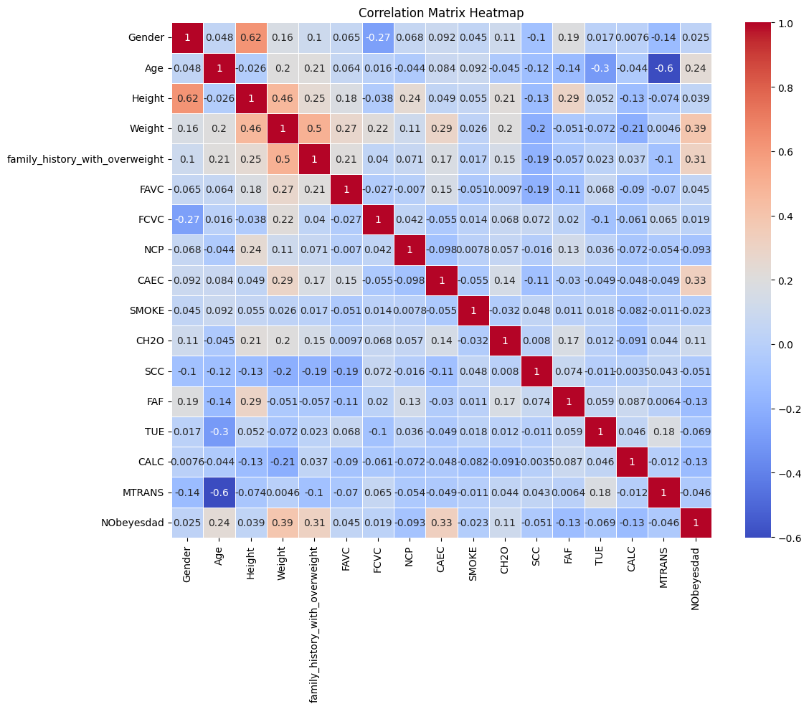

Fig. 1. Correlation matrix of key variables

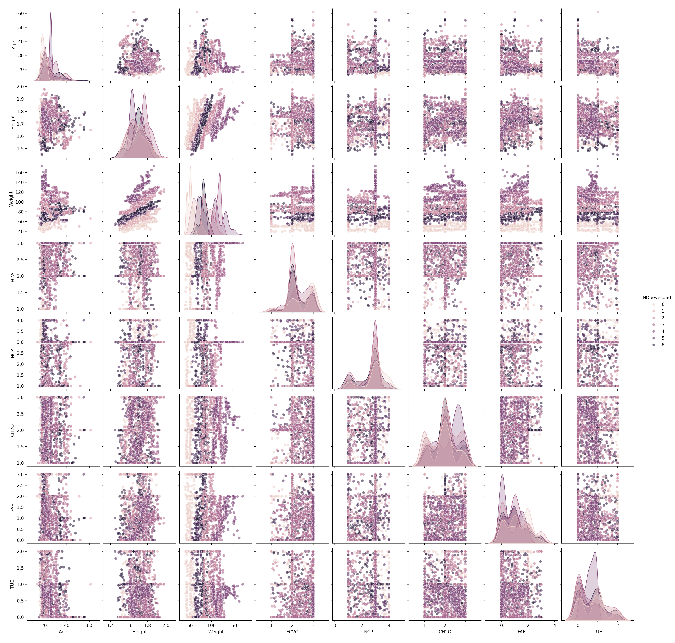

Fig. 2. Pairplot of selected variables

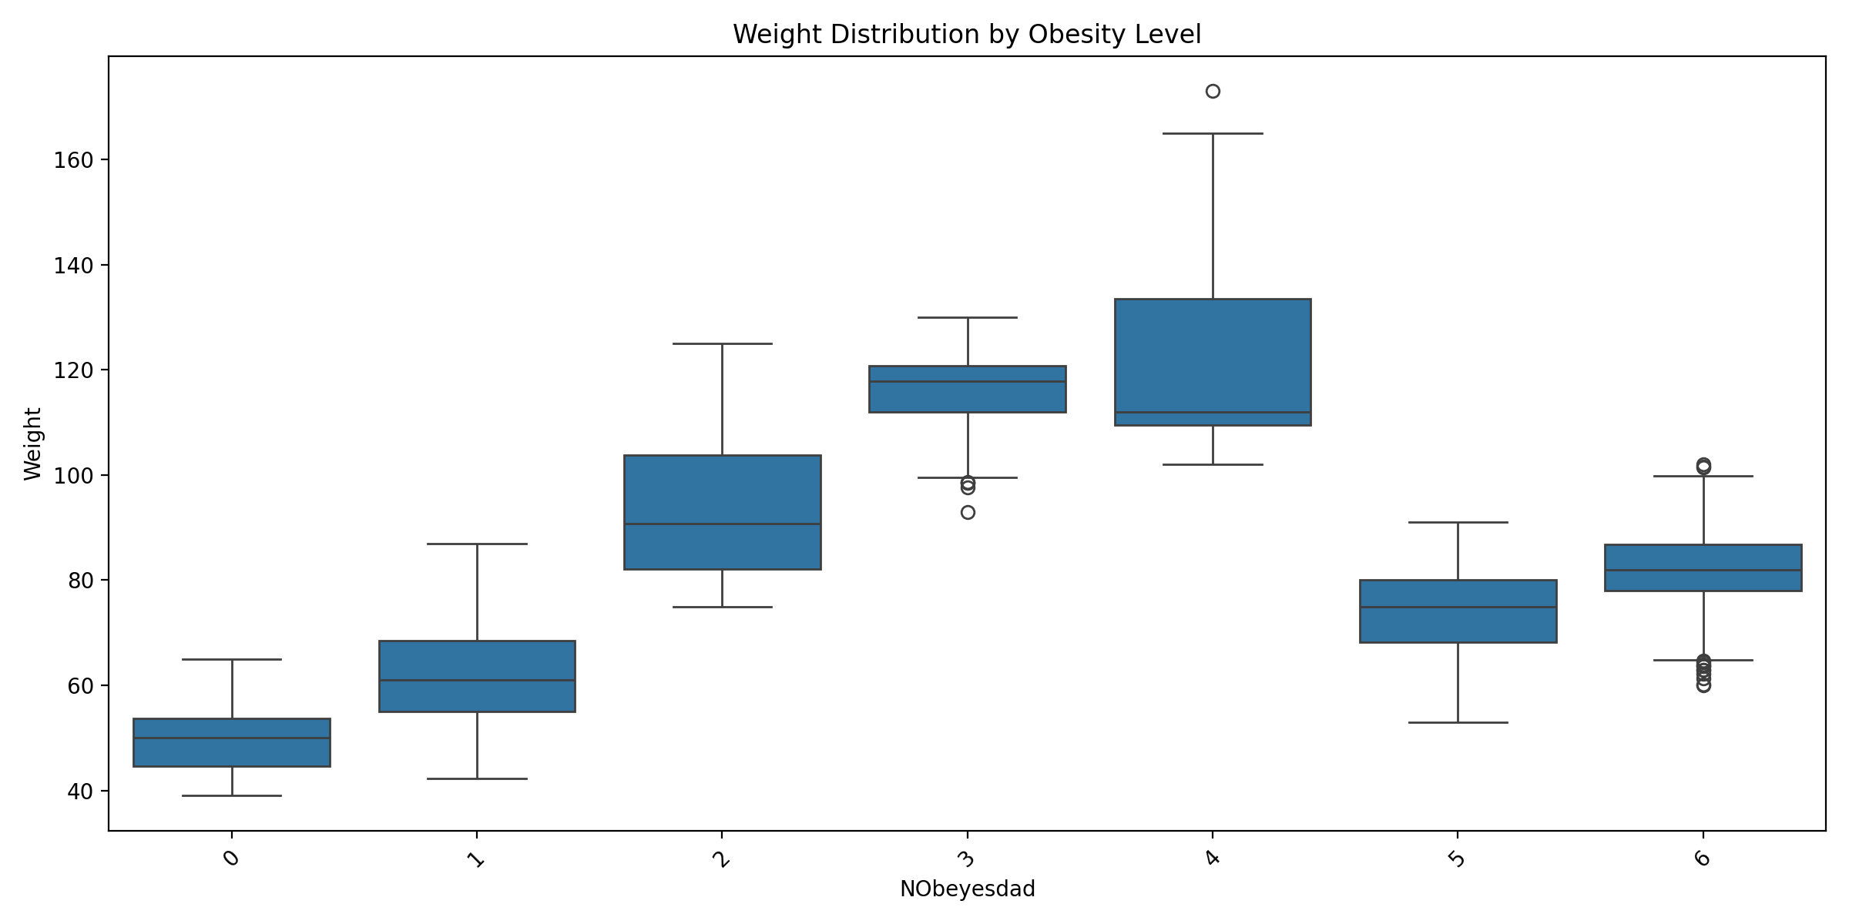

Fig. 3. Boxplot of weight distribution across obesity levels

## B. Regression Analysis

We performed linear regression to predict obesity levels based on the available features.

Fig. 4 shows the actual vs predicted values from our linear regression model.

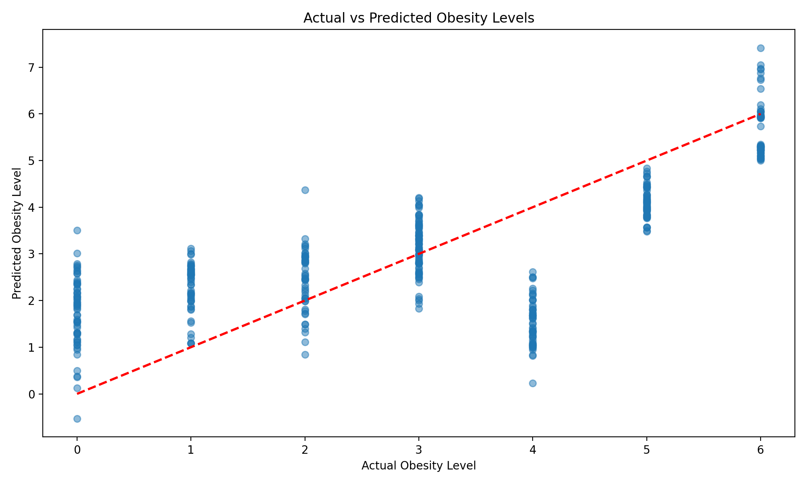

Fig. 4. Actual vs Predicted obesity levels

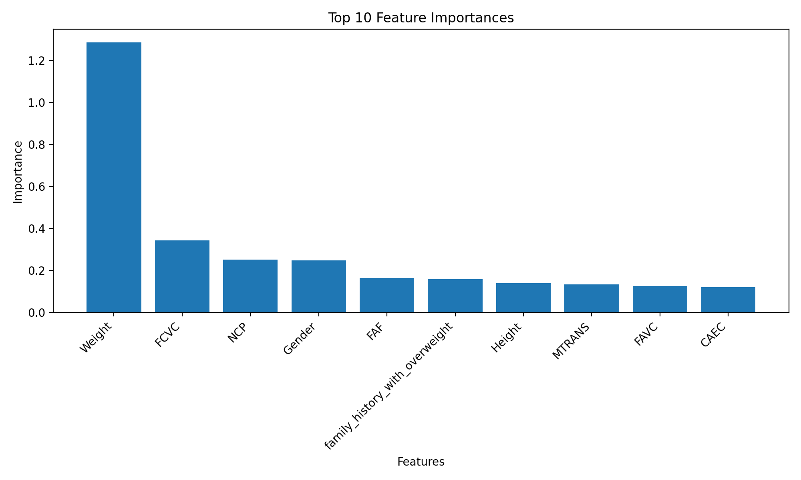

Fig. 5. Feature importance in predicting obesity levels

## C. Clustering Analysis

We applied three clustering algorithms: K-means, Hierarchical Agglomerative Clustering (HAC), and DBSCAN to identify potential patterns in the data.

Fig. 6 visualizes the results of our clustering analysis.

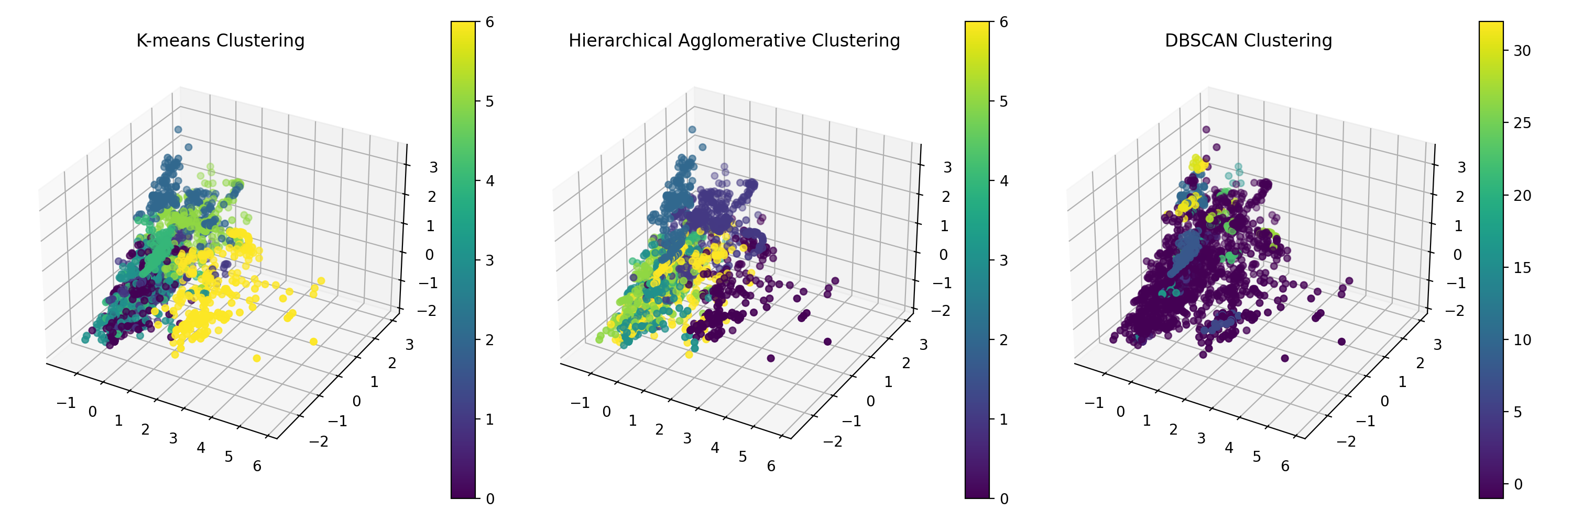

Fig. 6. Visualization of clustering results

Fig. 7 shows the distribution of samples across different clusters for each clustering method.

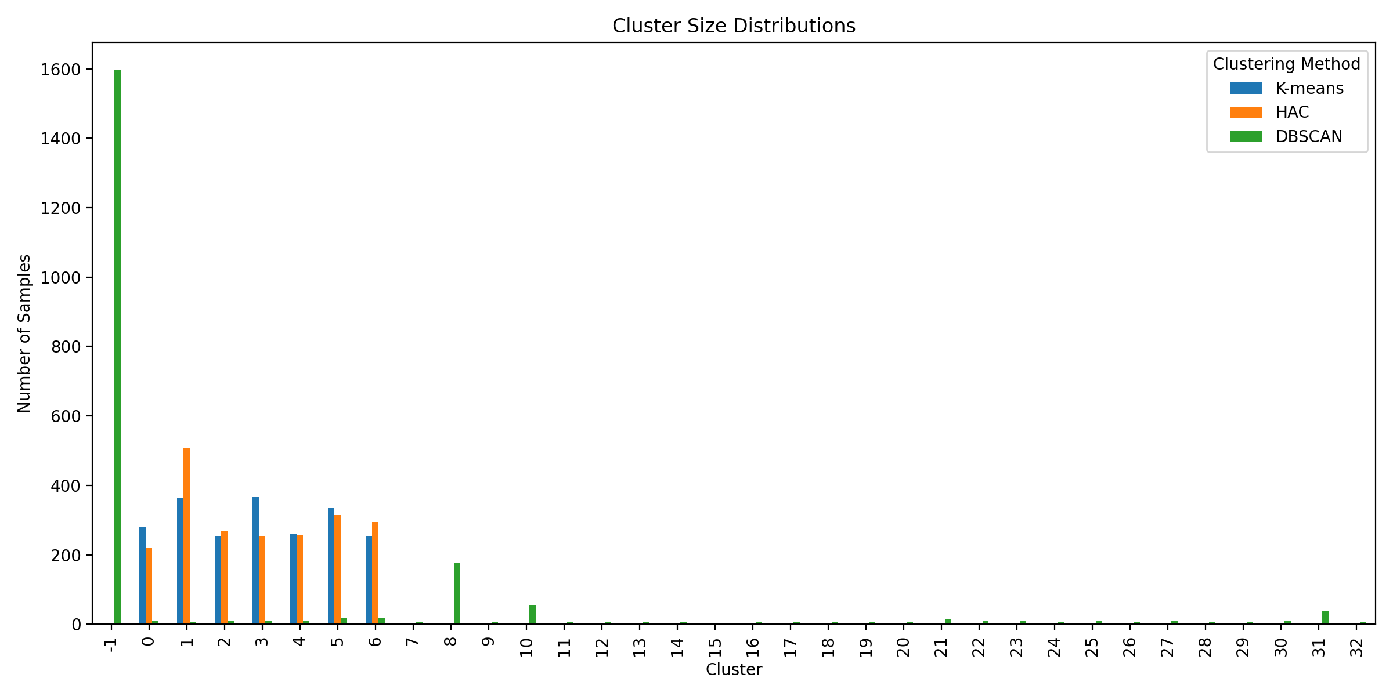

Fig. 7. Distribution of samples across clusters

# Results

The performance of the models was evaluated using various metrics. For classification models, accuracy, precision, recall, and F1-score were used. The SVM model achieved an accuracy of 96%, while the Decision Tree model achieved 94%. For regression, the R-squared value was 0.5056, indicating moderate predictive power. Clustering evaluation was performed using the Silhouette Score, with K-means achieving the highest score of 0.1658. Visualizations such as confusion matrices and ROC curves were used to further assess model performance.

# Discussion

The results of this study highlight the significant role of weight, dietary habits, and physical activity in predicting obesity levels. The classification models demonstrated high accuracy, indicating their potential for practical applications in obesity risk assessment. Challenges encountered included handling missing data and ensuring model generalizability, which were addressed through data preprocessing and cross-validation. Ethical considerations include the potential for bias in model predictions and the need for careful interpretation of results in real-world settings. The findings underscore the importance of personalized interventions and the potential for machine learning to inform public health strategies.

# Conclusion

This study has successfully identified key factors contributing to obesity, including weight, dietary habits, and physical activity. The developed models demonstrate high accuracy in predicting obesity levels, offering potential applications in personalized health assessments and targeted intervention strategies. Future research could focus on incorporating longitudinal data to capture temporal changes in obesity risk factors and exploring more advanced machine learning techniques such as deep learning for improved predictive performance. Additionally, investigating the impact of environmental and socioeconomic factors on obesity could provide a more comprehensive understanding of this complex health issue.

Github Link: https://github.com/dineshram18/Final_Project_ML.git